**Acknowledgement**

This project report consumed huge amount of work, research, passion and dedication.

In performing this project, we had to take help and guidance of some respected people, who deserve our greatest gratitude. The completion of this project gives us much pleasure.

We owe a profound gratitude to our project in-charge, Dr. Neepa Shah, who not only introduced us to the methodology of work but also took a keen interest in our project and guided us all along.

In addition, we would also like to thank our respected Principal, Dr. Hari Vasudevan, and the Head of Department, Prof. Neepa Shah, for giving us the support and guidance to work on this report.

We are also thankful to the college for providing us with the necessary resources and also many thanks to the staff of college for their valuable co-operation.

Many people, especially our classmates and team members itself, have made valuable suggestions which gave us an inspiration to improve our project. We thank them all for their help to complete the report.

Nevertheless, we express our gratitude towards the countless individuals who shared their knowledge and helped us in this report.

And finally, we are immensely grateful to all involved in the project as without their inspiration and immensely valuable suggestions it would not have been possible to develop the project within the prescribed time.

**Abstract**

Obesity and faineancy is a common trait seen among the youth of this generation, which is are a result of exercising less and eating more. The appetite of the current and upcoming generation has undergone a drastic change since the revolution in food industry and it is the kind of change that has shown a negative effect on the people of today’s era. The technological advancement has reduced the metabolism of the human body. All these leading to higher cholesterol levels and heart diseases.

An Online Fitness Recommendation System is a computer system that provides direct and customized instructions and fitness plans to the users. A range of different technologies are employed to achieve its functionality.

It is a platform designed to help people maintain in the peek of their health with the help of technology. It aims to reduce the high obesity rates and health problems seen among most of the citizens nowadays. The following project report gives a detailed overview about our Fitness Recommendation System. It includes all the details about the design and implementation of the project.

**List of Figures**

|  |  |  |
| --- | --- | --- |
| **Figure No** | **Figure Title** | **Page No** |
| 2.1.1 | Site Map | 11 |
| 3.1.1 | Site Structure | 14 |
| 3.1.2 | Home Page | 19 |
| 3.3.3 | Login Form | 21 |
| 4.1.1 | Sign Up and Register Form | 22 |
| 4.1.2 | BMI (Body Mass Index) | 21 |
| 4.1.3 | BMR (Body Metabolic Rate) | 23 |
| 4.1.4 | Weight Calculator (Loss / Gain) | 23 |
| 4.1.5 | Location of Fitness Centers | 24 |
| 4.1.6 | Profile Card | 25 |
| 4.1.7 | Successful login | 25 |
| 4.1.8 | Workout videos | 24 |
| 4.1.10 | Contact | 25 |
| 7.0 | Feedback form | 28 |
| 8.0 | References | 29 |

**List of Tables**

|  |  |  |
| --- | --- | --- |
| **Figure No** | **Figure Title** | **Page No** |
| 1 | Software Requirement | 11 |
| 2 | TimeLine Chart | 12 |
| 3 | Test Cases | 24 |

**Table of Contents**

1. **Analysis.** 
   1. Motivation for the project
   2. Problem Definition
   3. Scope
2. **Planning.** 
   1. Sitemap/ Navigation
   2. Computing environment
   3. Project implementation schedule
3. **Design.** 
   * 1. Construction and Design
     2. Designing site structure
     3. Navigation
     4. Page layouts
     5. Database Design
4. **Implementation**
5. **Testing and Deployment**
6. **Future Scope**
7. **References**
8. **Assignment No. 01**
9. **Assignment No. 02**
10. **Analysis**

**1.1 Motivation for the project**

The most common feature seen among the youth of this century is not hard work and dedication, but obesity and faineancy. These symptoms are a result of exercising less and eating more.

As of the 20th century, the advancement in technology has stunted the human growth making the upcoming generations of children as well as adults lazier and reducing the metabolism an average human body must possess.

The onscreen time has been prolonged up to 8 hours a day which has an annihilating consequence on the human anatomy. There has been a steep increase in the obesity rates and birth defects. By thorough analysis and surveys, it has been proven that people are getting unfit day by day. It is a need of the hour that health is wealth. But one thing that people are most demotivated by is that content related to health is available on the internet but everything is scattered and as such no meaning can be made out of it.

Content available on the internet is often misleading, because of which people end up experimenting wrong exercise techniques that are Trying to consolidate all that stuff is the need of the hour.

**1.2 Problem Definition**

The most common feature seen among the youth of this decade is not hard work and dedication, but obesity and faineancy. These symptoms are a result of exercising less and eating more. As of the 20th century, the advancement in technology has stunted the human growth making the upcoming generations of children as well as adults lazier and reducing the metabolism an average human body must possess. The onscreen time has been prolonged up to 8 hours a day which has an annihilating consequence on the human anatomy. There has been a steep increase in the obesity rates and birth defects. Taking into consideration the major factors there seemed to be a need for a web-based site that would help today’s youth manage their daily stressful commute by providing them with enough of exercise routines so that their body renders the way it has to be. This website is built with a perspective of cutting down these effects seen on today’s generation and to stop the global epidemic in its tracks.

It may seem ironical to use a digital website to reduce the effects of technology, but that’s what is uncommon about this website. It does waste the user’s precious time by making him/her cling to the site, scrolling through pages. The content provided to the user is only the one that matters and motivates him/her to want to get up and get that fat burning. Upon registration the user is asked to input various parameters of the body such as (#all the measurements#). Based upon the choice of fitness training program the user is provided a fitness routine that he/she needs to follow for a particular time period.

**1.3 Scope**

**Main goals**

Define the site objectives (Functions and Features)

It calculates Body Mass Index i.e. it tells whether your body is overweight, underweight and normal according to the BMI ratios and standard values.

This system also calculates Body Metabolic Rate which gives the daily calorie intake for a person.

Target audience (User demographics, user goals, user activity pattern)

Irrespective of age and gender any person who is conscious about the well-being of their body can sign-up and get their workout plan. The website suggests personalised plans for each individual based on their daily activities, gender and their BMR.

1. **Planning**
   1. **Sitemap**



**Figure 1(Sitemap)**

* 1. **Computing environment**

**Software Requirements :-**

|  |  |  |
| --- | --- | --- |
| **Front-End** | **Back-End** | **Tools** |
| **Languages**   1. HTML5 2. CSS4 3. JavaScript 4. Bootstrap | **Languages**   1. PHP 2. JavaScript   **Databases**   1. MySQL | 1. Windows 10 2. Web browser-Google Chrome 3. Atom 4. XAMPP 5. Internet Connection installation of web frameworks |

**Table 2.2.1 (Software requirements)**

**Hardware requirements :-**

1. Intel core i5 processor
2. 8 GB RAM
3. 1 TB Hard-disk
   1. **Project Implementation schedule**

|  |  |  |  |  |  |  |  |  |  |  |  |  |  |  |  |  |
| --- | --- | --- | --- | --- | --- | --- | --- | --- | --- | --- | --- | --- | --- | --- | --- | --- |
| **Online Tutorial - Time Chart (2018)** | | | | | | | | | | | | | | | | |
| **Months** | | **July** | | | | **August** | | | | **September** | | | | **October** | | |
| **Weeks (no. of weeks)** | | **1** | **2** | **3** | **4** | **5** | **6** | **7** | **8** | **9** | **10** | **11** | **12** | **13** | **14** | **15** |
| **Planning**  () | Study existing system (1) |  |  |  |  |  |  |  |  |  |  |  |  |  |  |  |
| Requirement Analysis (1) |  |  |  |  |  |  |  |  |  |  |  |  |  |  |  |
| Preparation of schedule (1) |  |  |  |  |  |  |  |  |  |  |  |  |  |  |  |
|  | | | | | | | | | | | | | | | | |
| **Designing**  () | Basic layouts design (3) |  |  |  |  |  |  |  |  |  |  |  |  |  |  |  |
| Database Design (5) |  |  |  |  |  |  |  |  |  |  |  |  |  |  |  |
| Code Design (7) |  |  |  |  |  |  |  |  |  |  |  |  |  |  |  |
|  | | | | | | | | | | | | | | | | |
| **Implementation**  () | Home Page  Design (1) |  |  |  |  |  |  |  |  |  |  |  |  |  |  |  |
| Login & Sign Up (2) |  |  |  |  |  |  |  |  |  |  |  |  |  |  |  |
| Database Connection (3) |  |  |  |  |  |  |  |  |  |  |  |  |  |  |  |
| Adding Contents (3) |  |  |  |  |  |  |  |  |  |  |  |  |  |  |  |
| Feedback form (1) |  |  |  |  |  |  |  |  |  |  |  |  |  |  |  |
|  | | | | | | | | | | | | | | | | |
| **Testing**  **(3)** | Unit Testing (3) |  |  |  |  |  |  |  |  |  |  |  |  |  |  |  |
| Integration Testing (3) |  |  |  |  |  |  |  |  |  |  |  |  |  |  |  |
| Performance testing (3) |  |  |  |  |  |  |  |  |  |  |  |  |  |  |  |

1. **Design**

**3.1.1 Site Structure**

The Site Structure is a tree structure as shown the figure

**figure 2 (Site Structure)**

* + 1. **Navigation**

The main navigation happens through navigation bar.



**Figure 3 (Navigation)**

**3.1.3 Page Layouts**

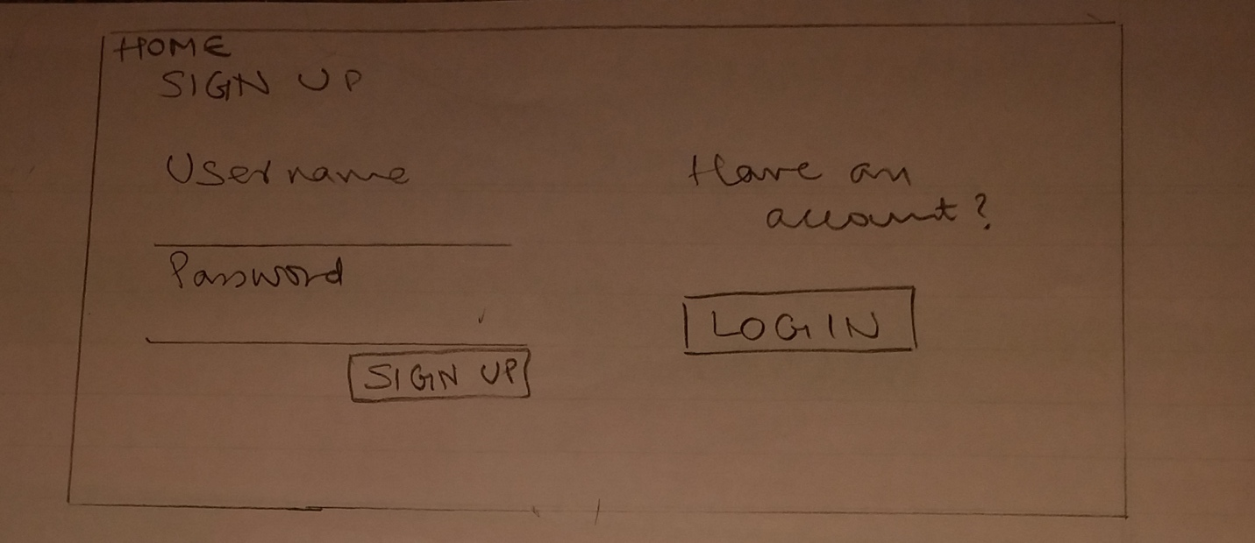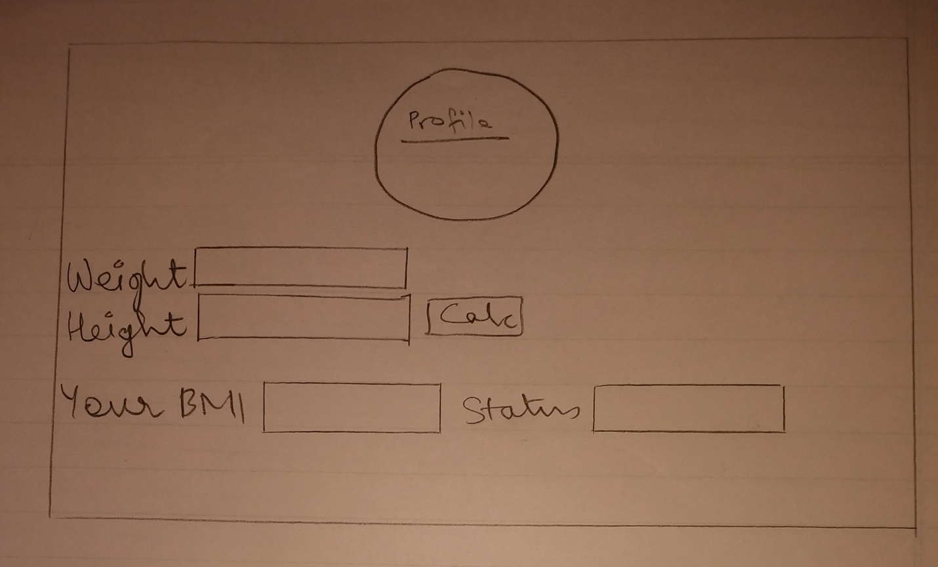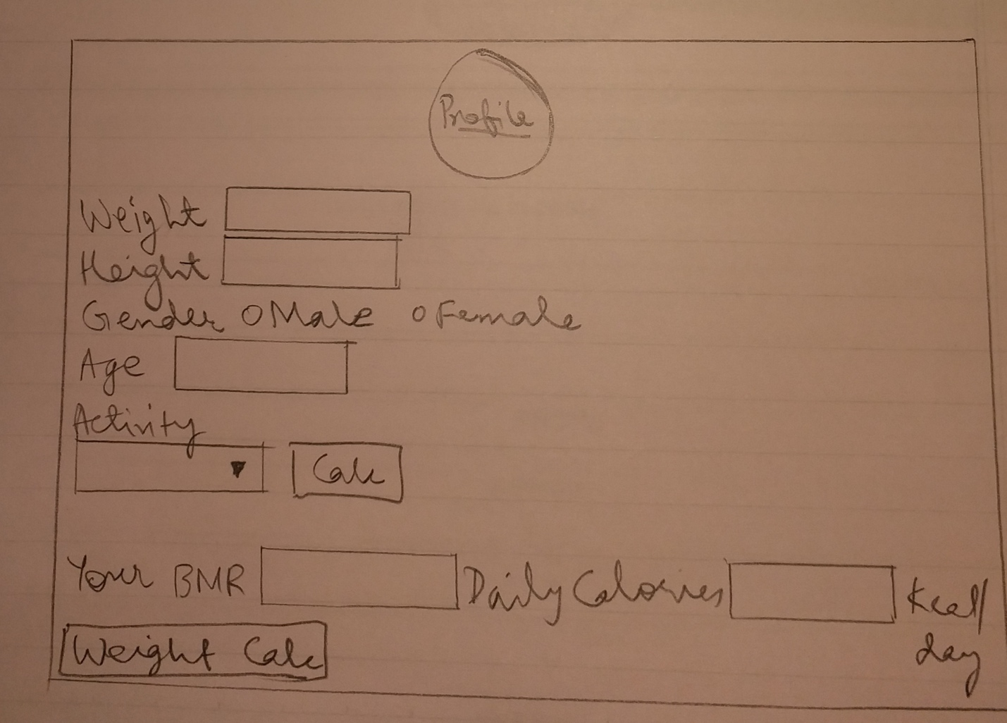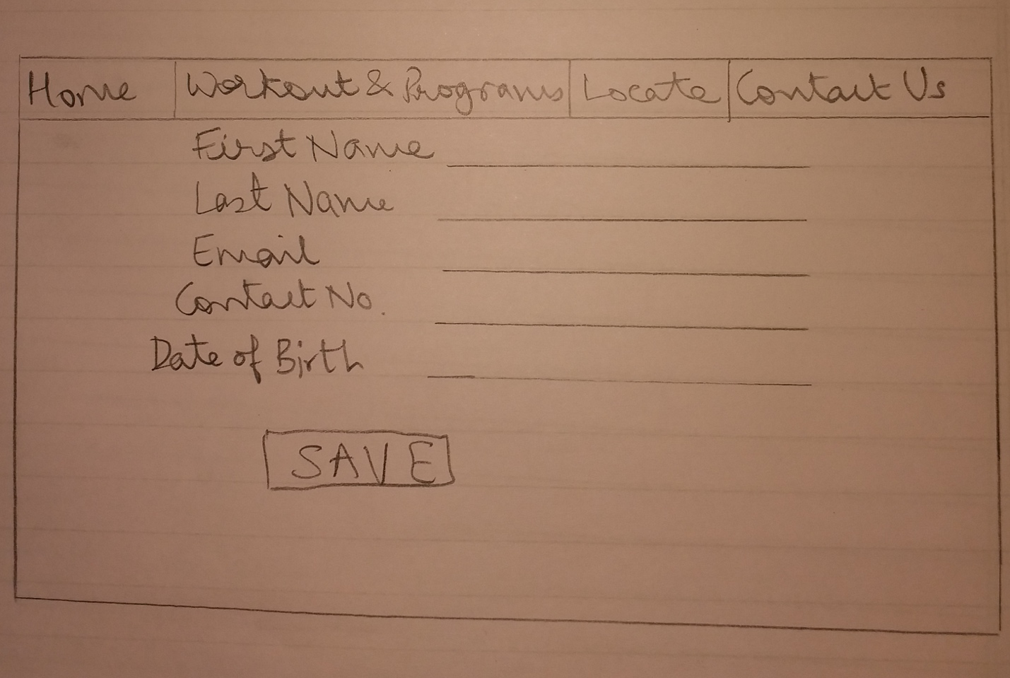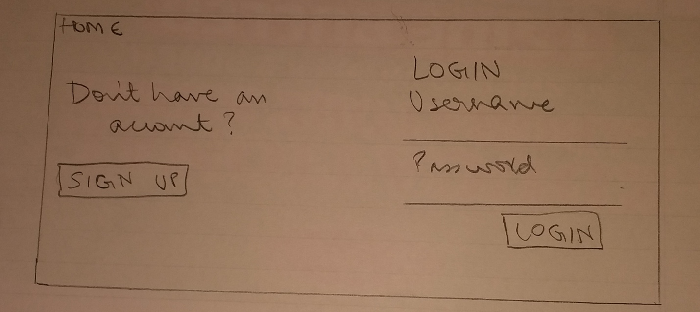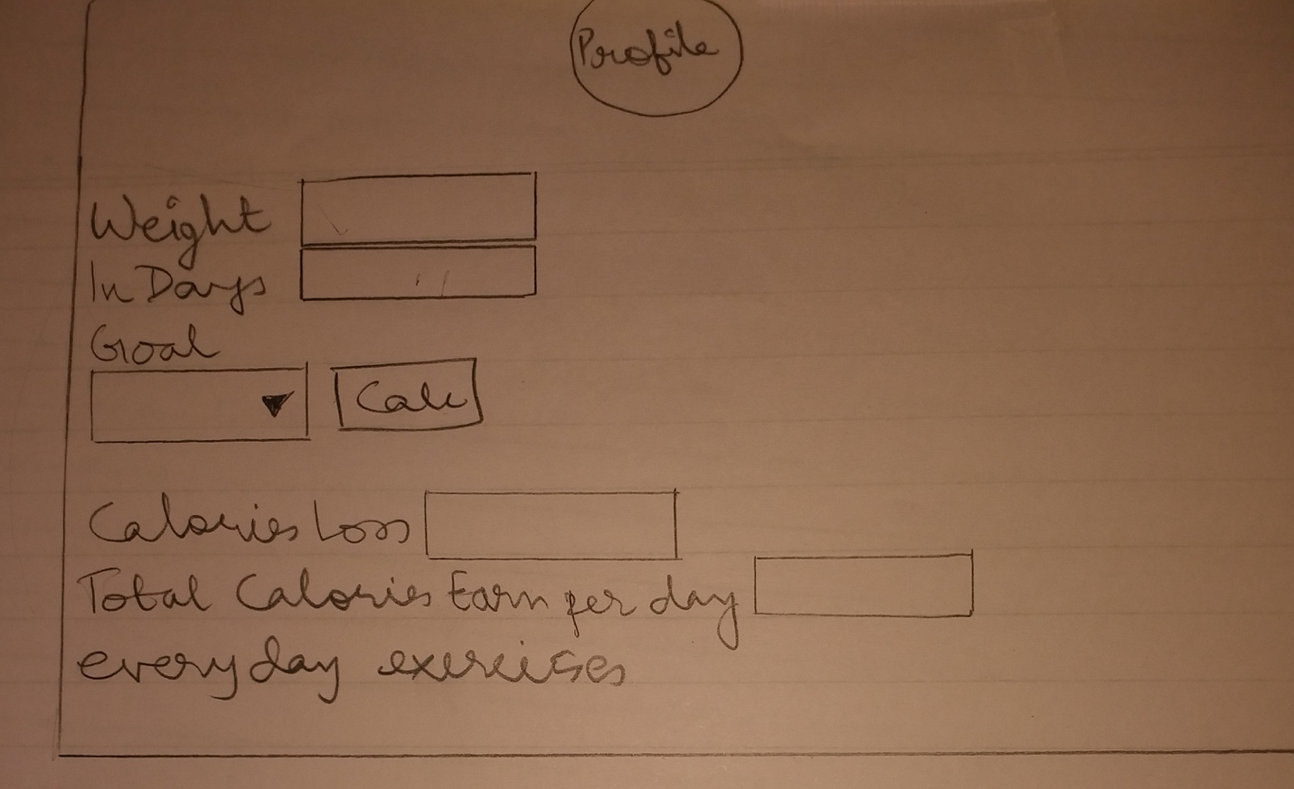

**3.1.5 Database Design**

The following figures show the database schema. There are three tables in our database.

Login Table Profile Table

|  |
| --- |
| User_id |
| Username |
| Password |

|  |
| --- |
| User_id |
| Fname |
| Lname |
| Email |
| Contact |
| d_o_b |

Contact Table

|  |
| --- |
| Name |
| Email |
| Review |
| Subject |

**4. Implementation**



**Figure 7(Home)**

This is the first page of the website. A very basic Homepage that consists Header, Footer, Navigation Bar that has following links:

1. Home (current page).

2. Workout & programs (Drop Down list).

3. Location

4. About Us

5. Login (for Login and Register).



**Figure 8(Footer)**

This is a Footer of our website which is present on the Home page in that the users can get our address through Google maps using Google maps API

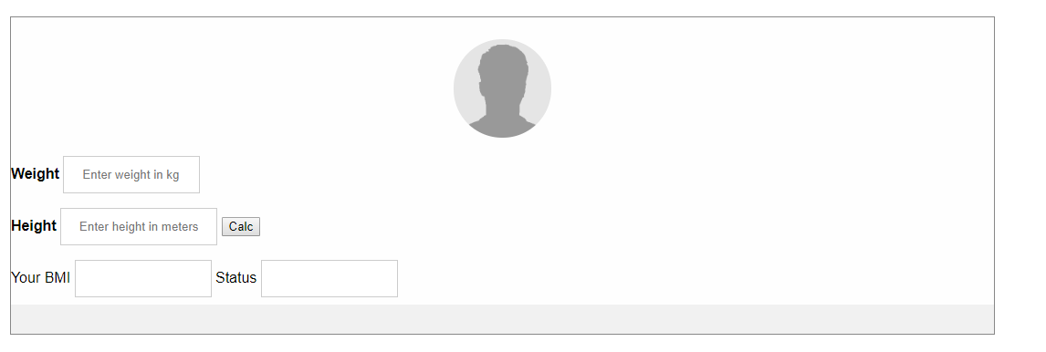

**Figure 9(BMI)**

This is a page which calculates BMI ratios of a body and sugest that your body is underweighted, overweight and normal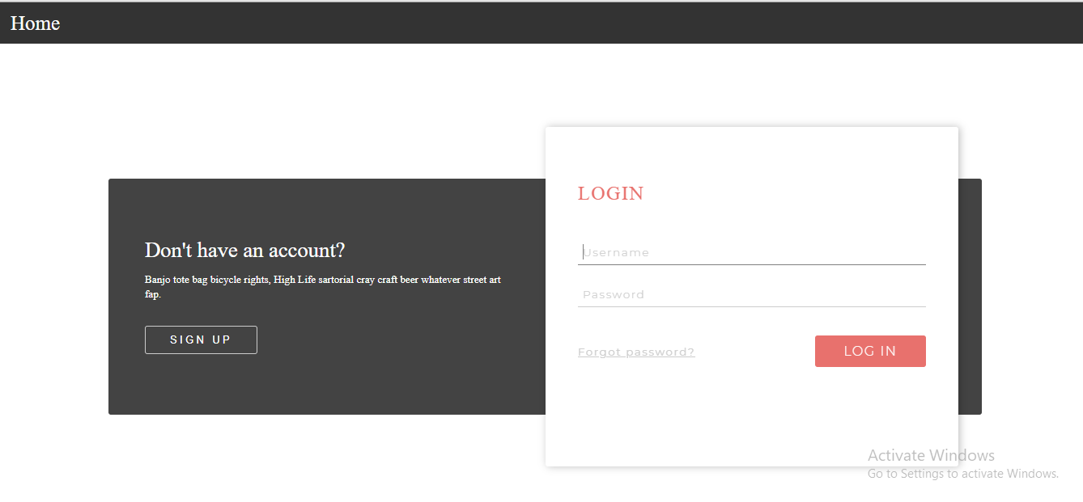

**Figure 10(Login)**

This is Login/Register page. There are two links Login and Register. It is a php file, consists of a form with two fields username, password and a submit button

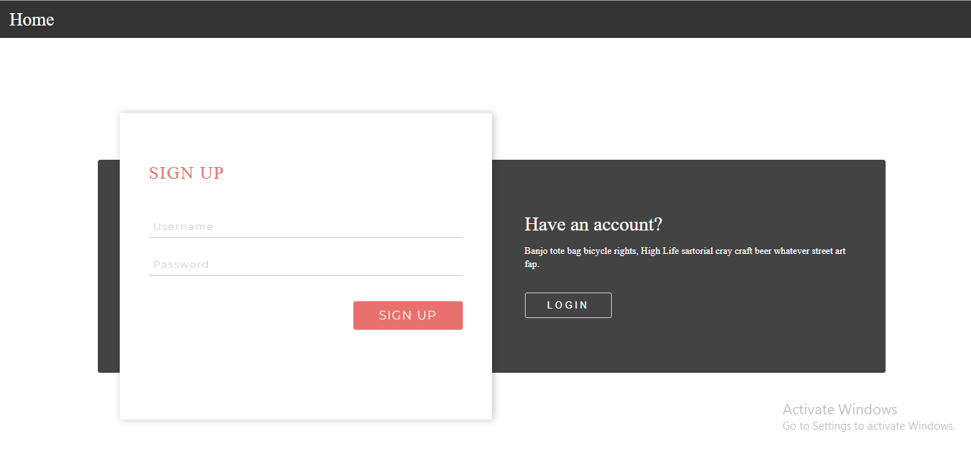

**Figure 11(Sign Up)**

This is the sign up page. It is also a php file. Takes two input from fields Username and Password and inserts them into database.

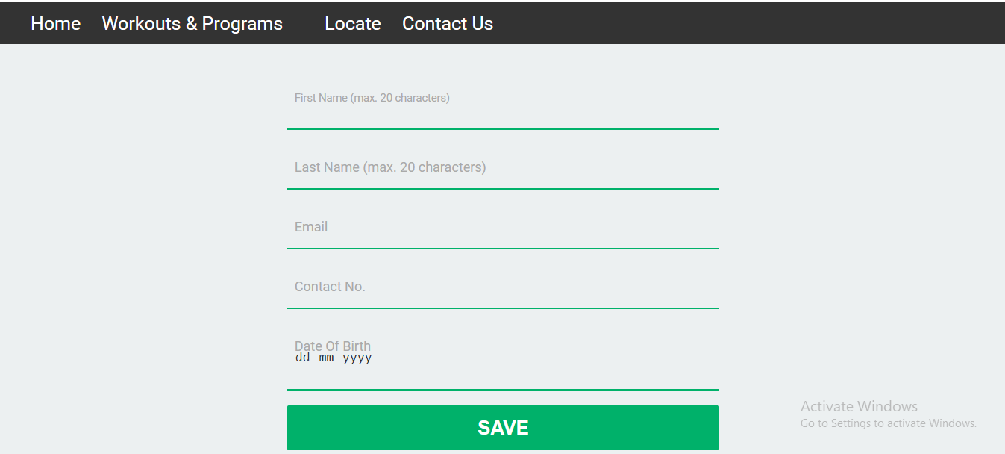

**Figure 12(Edit Profile)**

This is the Register page. It is also a php file. Takes the personal information of the users and store it into database of website.

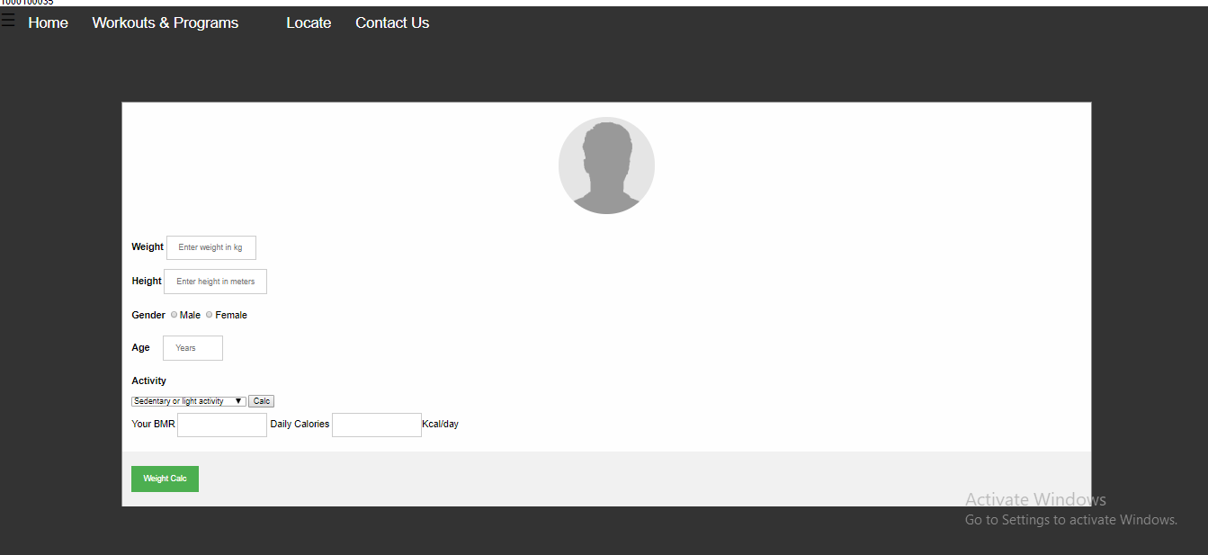

**Figure 12(BMR)**

This page is used to calculate BMR i.e Body Metabolic Rate which gives the daily calories earn per day

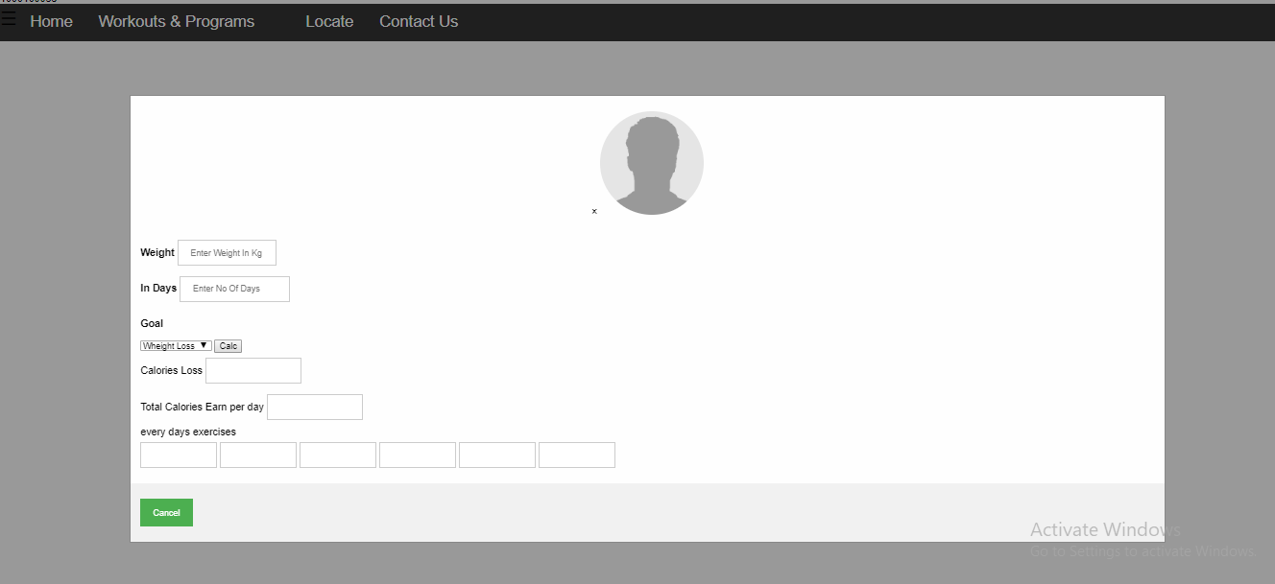

**Figure 13(Weight Calc)**

This page will calculate the calories earn per day according to the weight loss should be done in numbers of days and suggest exercises to be done every day to loss a particular weight.

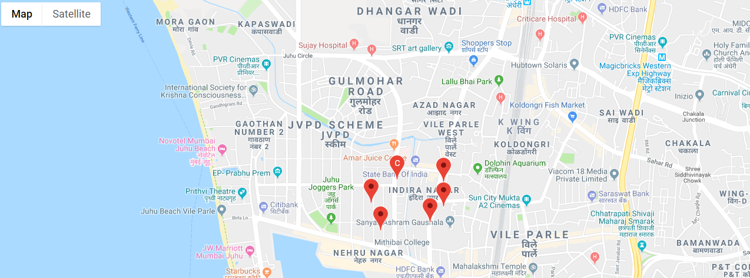

**Figure 13(Location)**

This page will give the users location of nearby gyms for their particular locations.

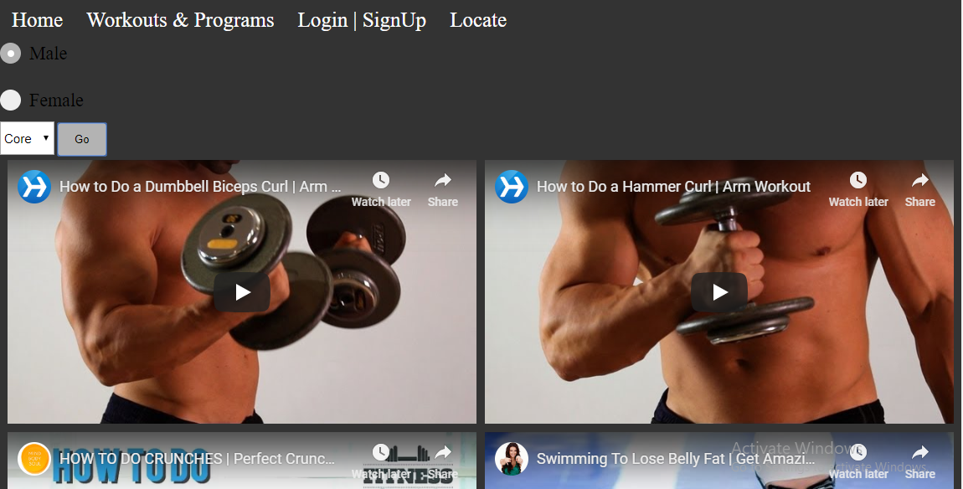

**Figure 14(Video page)**

This is the page will give a list of YouTube videos to the users according to their preferences.



This page shows the information of users stored in the database of website

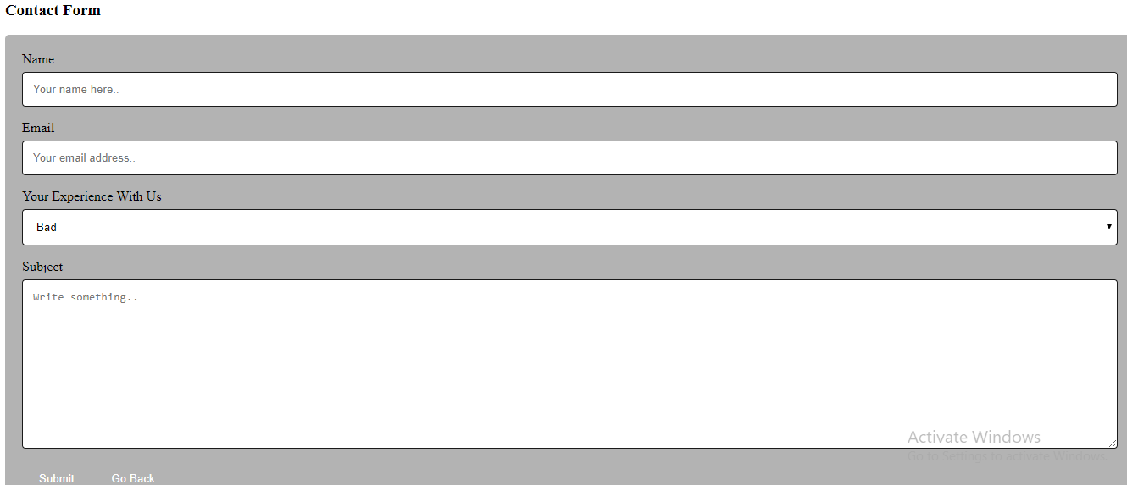

**Figure 15(Contact Us)**

This is the contact Us page. It lets the users to send a suggestion

1. **Testing and Deployment**

**Test Cases:**

|  |  |  |  |  |
| --- | --- | --- | --- | --- |
| **Test Case ID** | **Test Case** | **Expected Output** | **Actual Output** | **Result** |
| 1 | Login Username and Password | Login Successful | Login Successful | Pass |
| 2 | Registration | Registration Successful | Registration Successful | Pass |
| 3 | BMI | BMI Ratio | Body Status  And BMI Ratios | Pass |
| 4 | BMR | Calories earn per day | Calories earn per day | Pass |

**Deployment /Hosting:**

We have planned to host the website on a free domain 000WebHost with limited storage facility.

* 1. **Maintenance**
* **User Manual**
  + **General (Home page)**

The home page will give the overview of the website.

Their 4 more Workout & Programs, Locate gyms, My profile, Workout Videos.

* **Workout and Programs**

There are three drop list i.e. BMI, BMR.

These two terms are used to judge the user’s body by calculating the standardized value of BMI ratio and also suggest the exercises.

* **Login**

The User who have register successful they have extra features to the website by logging in.

The User will get BMI and BMR calculator through which user will get the idea about how fat or how thin are they.

Also, they can contact admin through Contact Us section in the user login.

* **Register**

Here the user who are interested will give their own personal information to the website database.

1. **Future Scope**

As day by day people are becoming more conscious about their fitness so the people who are actually wants to knows how their body is lagging behind the ideal body which should be maintained to stay fit or sporty.

Also, this website will help users in achieving fit body by suggesting some of the exercises which can be done easily in the house to lose some of the calories which is mandatory to do on daily basis for achieving the ideal body.

Health and Fitness are the evergreen industry the people will always been hungry on making their body fit irrespective of their ages and genders.

This website having the functions to calculate BMI and BMR terms which is very useful to suggest the users body status and accordingly help them.

**7.0 User feedback**

https://docs.google.com/forms/d/e/1FAIpQLSfdHhQxaZfFBBTf0o7MhBoc3xxzXBibniF-8xK8jlv2zNxC_A/viewform?usp=sf_link

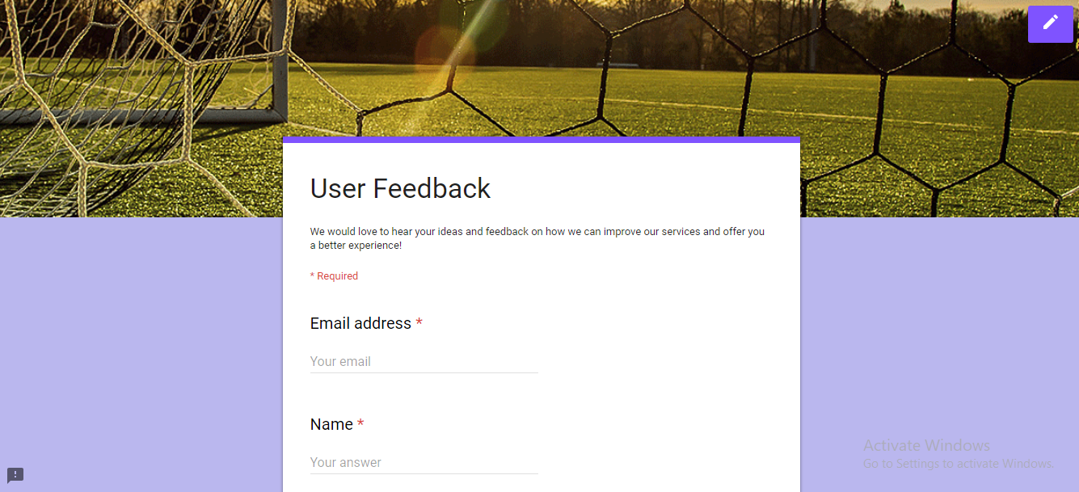

**Figure 16 (Feedback Form)**

The User feedback is important as to know what changes should be done in the future. Various parameters are covered in this form like Appearance, ease of navigation, Response time, user friendly and browser compatibility.

1. **References**
   1. <http://php.net/manual/en/index.php>
   2. <https://devdocs.io/javascript/>
   3. <https://console.developers.google.com/apis/library/places-backend.googleapis.com?filter=category:maps&id=ecefdd63-ee2b-4751-b6c3-8e9113791baf&project=my-project-1540099280731>
   4. <https://www.verywellfit.com/how-many-calories-do-i-burn-every-day-3495464>
   5. http://www.coachmag.co.uk/fitness